Volvo Penta Script for Excel files 2

Volvo Penta Export Blue Cells 3

Importert module 3

Read instructions before you run scripts 4

Following functions: 5

ChangeRow_TT 5

SplitSheets_ TT 5

SplitSheetsToColumns_TT  5

HideRow_One_TT  6

Volvo Penta Export Tur Cells 7

ChangeRow_one_TT  7

SplitSheets _TT  7

SplitSheetsToColumns_TT  8

HideRow_One_TT  8

Volvo Penta Import Script 9

Import module 9

Change_pt_OrgFile  *(Loop through each sheet in active workbook)* 10

Remove_pr  10

Rename it  11

MergeNoTransAndLang  12

ClearBeforeImportCol  12

MergeColumns  13

ChangeRowOneOrg  13

Rest_pt_OrgFile  13

Alignment 14

**Author: Daniel Elmnäs**

# Volvo Penta Script for Excel files

There are few steps you have to prepare before you run the scripts

Create following folders to get the structure.



You have to give the original-file a shorter filename example:   
(UCHP Penta Translation_Complete_2014-12-15_MISSING_v2.xls)  
because filename is to long approximately between 15-25 letters max.   
(Sometimes script engines crashes/can’t handle to long file-names when you run code)  
Result:”UHCP_Translation2.xls”

Also put following files in each folder

**(Blue_Cells)**

Volvo_Penta_Export_Blue_Cells.bas  
UCHP_Translation.xls



**(Tur_Cells)**



You find files on following locations:   
X:\Personliga mappar\Daniel\Egna Program och Script\EXCEL\Volvo_Penta_Export\Volvo_Export\Tur_Cells  
X:\Personliga mappar\Daniel\Egna Program och Script\EXCEL\Volvo_Penta_Export\Volvo_Export\Blue_Cells

Next step is to export Blue_cells and Tur_cells.

# Volvo Penta Export Blue Cells

## Importert module

Open the renamed file "UHCP_Translation2.xls" Press following buttons **"ALT"+ "F11"** to open "Microsoft Visual applications" window.  
Right click somewhere in the white window to the left (see picture).  
*Choose "Import Module"* navigate to the place and open”Volvo_Penta_Export_Blue_Cells.bas” press ok.

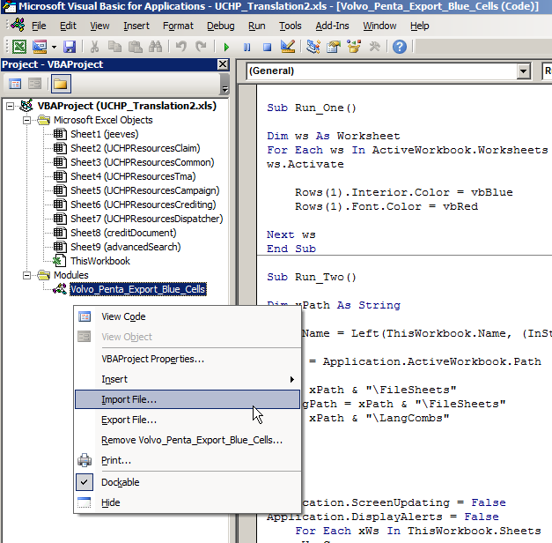

Double click in the list on”Volvo_Penta_Export_Blue_Cells” to see the code for the script.

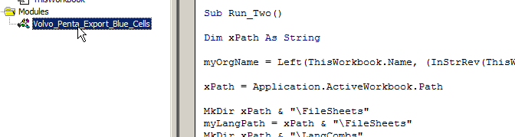

## Read instructions before you run scripts

When you are in the Microsoft Word window, press **“ALT” + “F11”,** to open “Microsoft Visual Applications”

**Before you press the play button!** 

You will press on the icon that looks like a play button to run the code. If there is no playbutton is it just an explanation of the function  
**OBS** before you press the button do following:

Put the insertion point somewhere in the text after the word **"Sub (Name of function)"**   
and not after **"End sub"** (end of the function)

You are then able to execute the function (code)  
 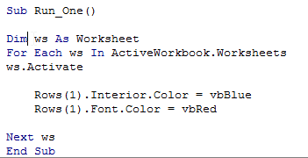

**Be careful so you don’t change anything in the code**

## Following functions:

### ChangeRow_TT

*(Loop through each sheet in active workbook).*Set background color VbBlue on row 1 and change font-color to red.



### SplitSheets_ TT

*(Loops through all the files)  
Choose the same folder as original file.*  
The script splits all sheets to separate excel files and gives a certain name: "(original -Filename)_(Sheetname).xls", also creates also following folders: "Filesheets" and "LangCombs".  
The script also moves the generated sheet files to the created folder "Filesheets".

### SplitSheetsToColumns_TT

* **Alignment_TT**

*(Loop through each sheet in active workbook)*

I have a function that sets the text content alignment to "left to right".

In some languages you write from **“right to left”** (Example Arabic)

* **GetCorWFromC_B_TT**

*(Loop through each sheet in active workbook)*

If the cell color is (Volvo Penta blue)

The script set font to black, also copying the text content from the cell in column B on the same row and paste it in the found blue cell.



* **SetNoneIBI_Col_TT**Set none color on interior background index

*(Loop through each sheet in active workbook)*

If the Color interior index is 6 (Yellow) change it to 9 (dark red)

This is to separate the cells from other cells.

* **SetYe_toDR_TT**

Set yellow to darkred

*(Loop through each sheet in active workbook)*

If the Interior color index is 3 (red) change it to 9 (dark red)

Also to separate the cells that already is red the other cells.

* **clearContent_TT**

*(Loop through each sheet in active workbook)*

If the cells have no background color (Xlnone) clear content.

* **clearcolumn_A_B_TT**

Selects Column A and B and clear content

* **SaveColumns_TT**

*(Loop through each sheet in active workbook)*

If each cell in row 1 and in each column is empty (have value >0) go to next, when found, select whole column and copy, create a new Excel document give the sheet name "Translated".

Save the file with (Original-filename)_(Sheet name)_(Language).xls Example:

“UCHP_Translation2_advancedSearch_es.xls”

Put all the generated Columns files in the folder **“LangCombs”.**

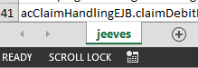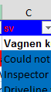

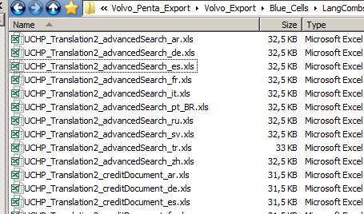

* **ColoRest_TT**

This script changes the interior color index on row 1 to none color (xlNone) also set the font color to black.

### HideRow_One_TT

Run the script select the folder where you put all the column files then press "OK"

The script hidden all cells on the first row each files.

Put all the Column files in following folder: “\Volvo_Penta_Export\Blue_cells\LangCombs”

This is these files the translator will use!

**Done!**

# Volvo Penta Export Tur Cells

The reason to have use two different export scripts it’s to separate the text in cells that actually will be translated, from cells that contains text, also cells that contain an interior color index.

Open following file from the folder structure:   
Volvo_Penta_Export\Tur_Cells\UCHP_Translation2.xls  
Import following module like you did in the previous export but instead module: **"Volvo_Penta_ExpTurk0311.bas"**

### ChangeRow_one_TT

*(Loop through each sheet in active workbook)*

Set background color VbBlue on row one and a red font on the text on row one.



### SplitSheets _TT

*Choose the same folder as original file.*  
The script splits all sheets to separate excel files and gives a certain name: "(original -Filename)_(Sheetname).xls".

It creates also following folders: "Filesheets" and "LangCombsNot".

The script also moves the generated sheet files to the created folder **"Filesheets"**.

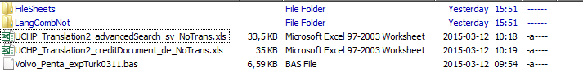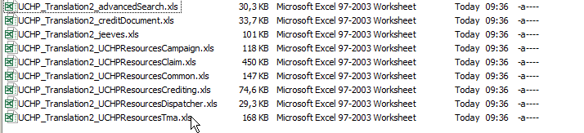

### SplitSheetsToColumns_TT

* **Alignment_TT**

*(Loop through each sheet in active workbook)*

I have a function that sets the text content alignment to "left to right".

In some languages you write from right to left (AR).

* **NoColTR_NoConT_T_TT**

No Color to red and no Color to Turquoise

*(Loop through each sheet in active workbook)*

The script selects following Columns **“A”** and **“B”** clear content.

For each cell if the Interior Color index that has no background color (XlNone) change to interior color index 3 (Red)

For each empty cell that has no content change the interior color index to value 8 (turquoise)

It’s because we need to separate the cells that actually have content from cells that has no content.

**SaveColumns_TT**Select the folder **“\Tur_Cells\Filesheets"** Press "ok".  
Each sheet contain X number of language columns.  
It's because the script generates a new file for each column give the file:  
 (Original-filename)_(Sheetname)_(Language)_Notrans.xls   
Example: UCHP_Translation2_advancedSearch_sv_NoTrans.xls



Put all the generated files in the folder \Volvo_Penta_Export\Tur_cells\LangCombNot\

### HideRow_One_TT

Run the script select the folder where you put all the column files then press "OK"

The script hidden all cells on the first row each files.

Put all the Column files in following folder: “\Volvo_Penta_Export\Blue_cells\LangCombsNot”

You will use the files when you Merge “*Notrans.xls” and “*(Lang).xls” later!

You have following folder structure:

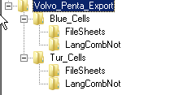**Done!**

# Volvo Penta Import Script

## Import module

You already have done an export and got following folder structure.



Copy following file in:”\Volvo_Penta_Export\Blue_Cells\UHCP_Translation2.xls”

To a folder you create somewhere: **”Volvo_Penta_Import”.**

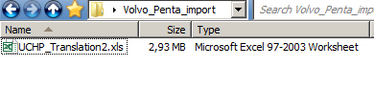

*Open the file then* ”Microsoft Visual Basic Applications” **(ALT + F11)**.

Right click in the white window in the list to the left, and choose "Import module"  
select this module:

X:\Personliga mappar\Daniel\Egna Program och Script\EXCEL\Volvo_Penta_Import\Volvo_Penta_import\

Import the file **“Volvo_Penta_Import31.bas”**

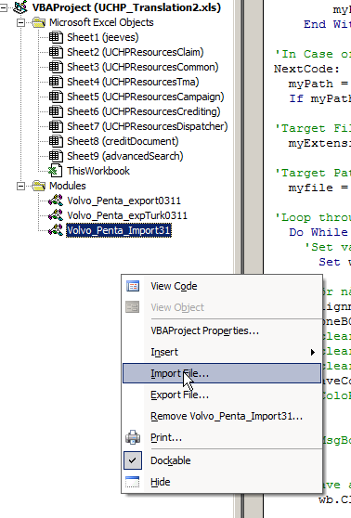

*Double-click on the script then so that you activate the code and run the following features*.  
Now it's time to use the files you received from the translator, we say you receive 90 translated files from the translator.  
Excel engine is not so strong so you cannot run all functions of all files simultaneously.   
Therefore, create folders 1, 2 on location:  
 **“\Volvo_Penta_import\”**



Where you put 45 files in each folder (translated files).  
Navigate then to folder: \Volvo_Penta_Export\Tur_Cells\LangCombNot\  
Get all Column files:”xxx_xxx_xxx.(Language)_NoTrans.xls”  
copy the files and add those 45 to folder 1 and 45 to folder 2.

### Change_pt_OrgFile *(Loop through each sheet in active workbook)*

Run this script on your opened file (”\Volvo_Penta_Import\Blue_Cells\UHCP_Translation2.xls”)

For each cell that is in row 1 and the text content **"pt_BR"** change it to **"br"**

### Remove_pr

This script is run to remove the same way that you removed **"pt_BR"** in the original file and changed to **"br"** so it's time to change all your files and partly översättarfilerna and even Notrans.xls files.  
located in the respective folders:  
”\Volvo_Penta_Import\Blue_Cells\1\”  
”\Volvo_Penta_Import\Blue_Cells\2\”

### Rename it

We need now to rename all the files in folder “1” and “2”  
Find “_pt_br” and replace with “_br”

*Use the program Rename-it:*

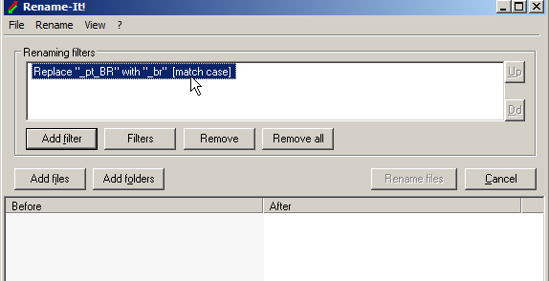

*Press on the button “filters” then select “Open”because I made a filter to do this:*

*X:\Personliga mappar\Daniel\Egna Program och Script\EXCEL\Volvo_Penta_Import\Volvo_Penta_import\pt_BR_remove.rit*

*Press add files select all from folder* ***“one”*** *and* ***“two”***

(“\Volvo_Penta_Import\”)

“*NoTrans.xls”  
“*(Language.xls)”  
*Make sure the filenames are* consistent *(language files) and (NoTrans files) is the same except “NoTrans”.*

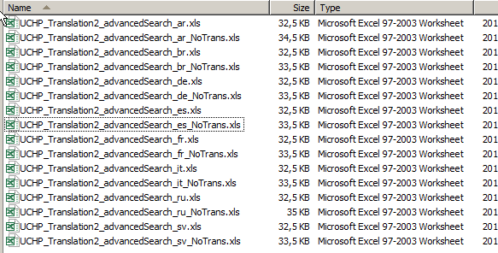

### MergeNoTransAndLang

*(Loops through all the files)*Select folders in this case (**"1"** and then **"2"**).  
**(“\Volvo_Penta_Import\)**  
For each file named “*_NoTrans" opens it.  
the script copy column (1) then,  
open the file in the same folder filter removes **"*_NoTrans"** paste in a new sheet as it creates called **"WordNotTrans"**, then activates the Sheet **"Translated"** (the translated sheet)  
Selects the entire first row and **show**.  
Enables sheet "WordNotTrans"  
For each cell Background Color interior 3(red).  
copy to Sheet "Translated" in the same place.  
Delete Sheet "WordNotTrans"   
Save file.

### ClearBeforeImportCol

*(Loops through all the files)*Select folders in this case (**"1"** and then **"2"**).Sets the background color = none  
font color = black  
If the cell has the background color (3) red = none  
if the cell has color value (8) Turquoise = none  
*Create a folder called* ***“Old_NoTrans”*** *in the same location as* ***“1”*** *and* ***“2”.****Put all files that have *_NoTrans.xls” in old_NoTrans*

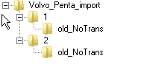

*Folder* ***“1”*** *and* ***“2”*** *should looks like this then.*

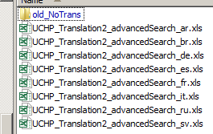

### MergeColumns

*(Loops through each column in sheet)*

*Use this on the open file* ***(UHCP_Translation 2.xls)****.  
You have to loop through manually each sheet to import the columns to same place.*

Select folders in this case (**"1"** and then **"2"**).  
For each cell in row 1 that has a text value if the cell contain text make a string then add the string to the currently Filename and open the file in the same location:  


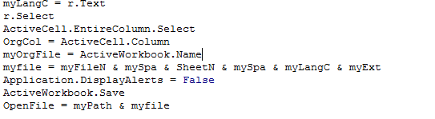  
Result :  
(Filename)_(Sheetname)_(Language).xls

Example sheet one:

(Sheet)  


(Column C)  


The script creates this string “UHCP_Translation2_jeevas_sv.xls”  
If the file does not exist message: ”File does not exist”.  
If the file does exist(UCHP_Translation2_Jeeves_sv.xls)  
Open the file select the same cell in the file then select the whole column copy  
enable Workbook (UCHP_Translation2)  
Paste the column on the same place.

### ChangeRowOneOrg

*(Loop through each sheet in active workbook)*Restore Color on row entire row 1 to none, also changing back font color to black.

### Rest_pt_OrgFile

*(Loop through each sheet in active workbook)*Restore **”br”** to **”pt_BR”** (In each cell Row 1 check after “br” change to “pt_BR”.

### Alignment

Don’t forgot to change back the alignment on text columns that you write from “right to left”   
(Example Arabic).

**Finally done!**

Written by Daniel Elmnäs